Standard XML Reporting

Instructions and Specifications

**Version 4.0**

###### 

Last Update: 31-Jan-2014

**Revision History**

|  |  |  |  |  |
| --- | --- | --- | --- | --- |
| **Rev** | **Date** | **Author** | **Description** | **Requestor** |
| 2.1 | May 19, 2008 | T. Breineder | Combined STR and CTR schemas | Maher Abu Ghali |
| 2.2 | June 04, 2008 | M Abu Ghali | Finalized version for the FIC Namibia | FIC - BON |
| 2.3 | June 06, 2008 | T. Breineder | Moved local currency element from the transaction details to the report element | Maher Abu Ghali |
| 2.4 | June 06, 2008 | T. Breineder | Amended account holder to include a flag specifying the primary signatory | Maher Abu Ghali |
| 2.4.1 | June 23, 2008 | M. Abu Ghali | Account Balance element added to t_account node | Maher Abu Ghali |
| 2.4.2 | July 30, 2008 | Ameen Safadi |  |  |
| 2.4.3 | August 28, 2008 | M. Zeeshan Tahir | Teller in Transaction was made optional. Differences between schema & documentation rectified. | Badi Alkhatib |
| 2.4.4 | August 29,2008 | Stefan Brezina | Consistency check and rework | Badi Alkhatib |
| 2.4.4 | September 12, 2008 | Ameen Safadi | Remove Entity Type lookup table from document, and clean some unused lookup values. No change in schema. |  |
| 2.4.5 | November 03, 2008 | Zeeshan Tahir | All date fields are bound to have values later than or equal to 1900-01-01 | Ameen Safadi |
| 2.4.6 | November 05, 2008 | Zayeem Khan | Several non-mandatory elements can now have blank values.  t_person/identification node can now be repeated.  City field can be up to 255 chars.  Phone number can be up to 50 chars.  rentity_id > =1.  IBAN length was raised to 34. | Ameen Safadi |
| 2.5 | May 05, 2009 | Zayeem Khan | Introduction of new nodes to mark my_client in the “from” and “to” sides of transactions.  Node for “gender” added to person node.  Pattern restriction removed from type "email_address".  Maxlength set to 255 for node "incorporation_state".  Revamped the whole document to have updated figures as per the latest schema, restructured some parts of the document, recreated all the broken links within the document and checked for correctness and completeness of the document as per the schema. | Maher Abu Ghali |
| 2.6 | June 03, 2009 | Scott Fulford | Several nodes under the various ‘my_client’ types from schema 2.5 have been made mandatory in 2.6 | Maher Abu Ghali |
| 3.0 | Jan. 07, 2010 | Ameen Safadi | Modify the document to reflect all the new features of schema 3.0 | Maher Abu Ghali |
| 3.1 | May. 18, 2010 | Ameen Safadi | Add new elements: fiu_ref_number, transation_location, transaction_description | Maher Abu Ghali |
| 4.0 | Jan. 31, 2013 | Ameen Safadi | Schema upgrade to release 4.0. | Maher Abu Ghali |
| 4.1 | 29 April, 2014 | Zayeem Khan | Minor corrections done, based on inputs from FIU-Morocco | FIU-Morocco |

Table of Contents

1. Summary 4

2. Conventions used in this document 4

3. Description of XML Nodes 5

3.1 Node “report” 5

3.11 Subnode report_indicators 7

3.2 Node transaction 8

3.3 Node Activity (New in Schema 4.0) 11

3.41 Node t_from_my_client 12

3.42 Node t_from 13

3.51 Node t_to_my_client 15

3.52 Node t_to 16

3.6 Subnode goods_services 17

4. Description Of Common Types Used in the Schema 19

*4.11 Type* t_account_my_client 19

*4.12 Type* t_account 22

4.21 Type t_entity_my_client 25

4.22 Type t_entity 27

4.31 Type t_person_my_client 29

4.32 Type t_person 32

4.4 Type t_party 35

*4.5 Type* t_address 37

4.6 Type t_phone 39

4.7 Type t_foreign_currency 40

4.8 Type t_person_identification 41

4.9 Type report_party_type 42

5. Lookup Values 43

5.1 Submission type – goAML Enumeration 43

5.2 Funds type 43

5.3 Account type 43

5.4 Account status type 44

5.5 Identifier type 44

5.6 Conduction Type 44

5.7 Transaction Item Status 44

5.8 Report Code – goAML Enumeration 45

5.9 Contact Type 45

5.10 Communication Type 45

5.11 Entity Legal Form Type 46

5.12 Transaction Item Type 46

5.13 Currencies - Enumeration 46

5.14 Country Codes - Enumeration 51

5.15 account_person_role_type 56

5.16 entity_person_role_type 56

# Summary

The purpose of this specifications document is to provide both the reporting entities and reporting persons with the requirements and conditions for creating compatible XML files using the provided XML- Schema for the different supported report types.

A report file contains the following information which can be represented in the goAML Client after uploading and verifying the XML file.

* Basic information about the report.
* Where does the money come from.
* Who conducted the transaction.
* Where does the money go to.
* Was the transaction related to a property transfer
* Who reported the transaction(s) (Optional)
* What was the reason for the report and which actions have been taken (Optional)
* In multi-party transactions, list of all involved parties and their respective roles in the transactions.

An XML report is linked to one Reporting Entity but may contain multiple transactions. An uploaded report can be from ONE report type.

This document will provide a reference to the schema, nodes and types as well as the lookup tables for enumeration values. (e.g. Country Codes)

# Conventions used in this document

The following conventions are used in this document:

|  |  |
| --- | --- |
|  | Required field  Required, 1 to N values |
|  | Optional field |
|  | Optional sub node  Required sub node |
|  | Optional, but one of the two nodes should be provided |
| Integer | A 32 bit value |
| Date time | A date and time value in the following format: YYYY-MM-DDTHH:MM:SS |
|  | Sequence to sub nodes |

# Description of XML Nodes

## 3.1 Node “report”

Basic information about Reporting Entity, reporting date and type of report. It can contain multiple transactions.

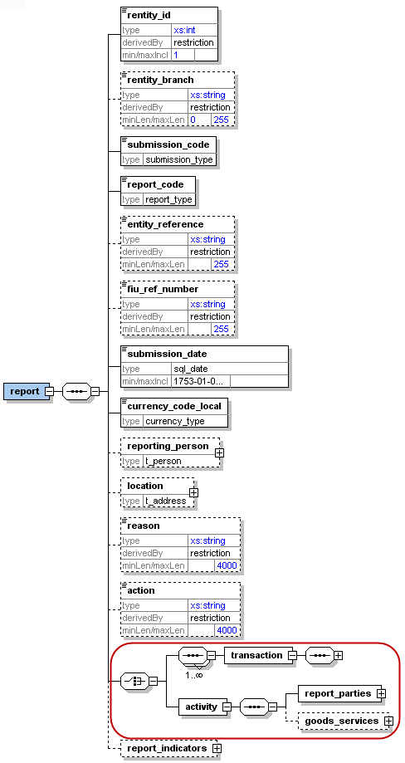

Figure 1: Overview node “report”

|  |  |  |  |  |  |  |  |  |  |
| --- | --- | --- | --- | --- | --- | --- | --- | --- | --- |
| **Name** | | **Description** | | **Length** | | **Req.** | | **Example** | |
| **rentity_id** | | Reporting Entity number defined by FIU | | Integer  >= 1 | | **Y** | | 1237 | |
| rentity_branch | | Branch of current reporting entity. | | 255 | | **N** | | Branch of Western Union whom reported the transactions | |
| **submission_code** | | Type of submission | | Enumeration | | **Y** | | See 5.1 Submission type | |
| **report_code** | | Type of transaction (STR/CTR) | | Enumeration | | **Y** | | 5.8 Report Code | |
| entity_reference | | Optional reference to the report, used by reporting entity | | 255 | | N | | STR Rep 392 | |
| fiu_ref_number  (New in Schema 3.1) | | Optional ref. number to be used as communication channel between the FIU and the Reporting Entity | | 255 | | N | | STR_20100217. FIU requests more info regarding a report, so RE can use that number in their reply | |
| **submission_date** | | Submission date and time | | Datetime | | **Y** | | 2006-03-25T11:55:00 | |
| **currency_code_local** | | Local Currency code | | Type “Currency-type” | | **Y** | | EUR | |
| reporting_person | | Full details of the report’s reporting person | | Type “t_person” | | N | | Can be forced mandatory in certain report types by using the new goAML feature: “XML Rejection Rules” | |
| Location | | Describes location of the reported report | | Type “t_address” | | N | | Mandatory: Same as “reporting pesrson” | |
| reason | | Why the report was reported (especially or STRs) | | 4000 | | N | | Mandatory: Same as “reporting pesrson” | |
| action | | Describes action related to the report | | 4000 | | N | | Mandatory: Same as “reporting pesrson” | |
| As of schema 4.0, Report could contain either a list of transactions as it was always or a list of involved subjects without the need of a transaction to link them. | | | | | | | | | |
| **transaction** | | Transaction information | | type  transaction | | **Y** | | See 3.2 Node transaction | |
| **Activity** | | Involved subjects and items list linked directly to report.  New in 4.0 | |  | | **Y** | | See 3.3 Node activity | |
| report_indicators | | List of indicators for the current reports | | Type “indicator” | | 0..many | | See 3.11 Subnode report_indicators | |

Table 1: Details node “report”

## 3.11 Subnode report_indicators

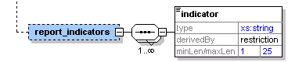

Figure 2: Overview subnode report_indicators

|  |  |  |  |  |
| --- | --- | --- | --- | --- |
| **Name** | **Description** | **Length** | **Req.** | **Example** |
| indicator | Some classification for the report | 25 | **Y** | Crime,  Terror Funding, etc.  (FIU predefined list of codes) |

Table 2: Details subnode report_indicators

## 3.2 Node transaction

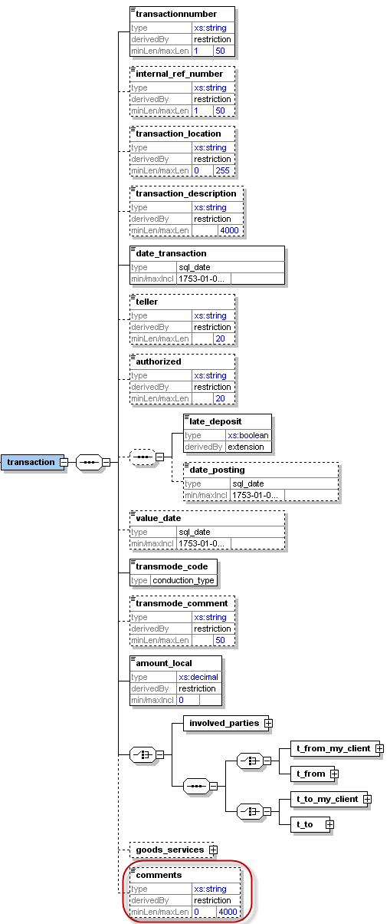

Figure 3: Overview node transaction

|  |  |  |  |  |  |  |  |  |  |  |
| --- | --- | --- | --- | --- | --- | --- | --- | --- | --- | --- |
| **Name** | | **Description** | | **Length** | | | **Req.** | | **Example** | |
| **transactionnumber** | | Unique transaction number for bank transaction | | 50 | | | **Y** | | 20084711 | |
| Internal_ref_number | | Reporting Entity internal transaction reference number | | 50 | | | N | | WU_BRNCH01_0001 | |
| transaction_location  (New in Schema 3.1) | | Branch/Location where the transaction took place | | 255 | | | N | | Branch 001 | |
| transaction_description  (New in Schema 3.1) | | Free text field to describe the purpose of the transaction | | 4000 | | | N | |  | |
| **date_transaction** | | Date and time of the transaction | | DateTime | | | **Y** | | 2006-03-25T11:55:00 | |
| teller | | Who conducted the transaction | | 20 | | | N | | ID88933345 | |
| authorized | | Who authorized the transaction | | 20 | | | N | | ID00033345 | |
| *late_deposit* and *date_posting* are both optional but when setting *date_posting,*  *late_deposit* becomes mandatory.  3 possible combinations  1. none of the nodes is set  2. only *late_deposit* is set  3. *late_deposit* AND *date_posting* are set | | | | | | | | | | |
| **late_deposit** | | Late deposit indicator | | Boolean | | | **Y/N** | | True | |
| date_posting | | Date of posting (if different from date of transaction) | | DateTime | | | N | | 2006-03-24T19:55:00 | |
| value_date | | Value date | | DateTime | | | N | | 2006-03-27T00:00:00 | |
| **transmode_code** | | How the transaction was conducted | | Enumeration | | | **Y** | | See 5.6 Conduction Type | |
| transmode_comment | | Description if transmode_code is “O” (Other) | | 50 | | | N | | - | |
| **amount_local** | | The value of the transaction in local currency | | Decimal | | | **Y** | | - | |
| Transaction could be either a bi-party transaction with clear From and To sides, or a multi-party transaction with unlimited list of subjects (Persons, Accounts and Entities) where each has a role in the transaction rather than a clear from or to side. | | | | | | | | | | |
| Bi-Party Transaction | | | | | | | | | | |
| One of the nodes *t_from_my_client* or *t_from* should be provided. Both CANNOT be present together in a transaction, but one of them should be present. | | | | | | | | | |
| **t_from_my_client** | | Specifies where the money came from. If the source is reporting bank’s client, then this node should be provided | | Subnode | | | **Y**  (one of them) | | See t_from_my_client |
| **t_from** | | Specifies where the money came from | | Subnode | | | See 3.42 Node t_from |
| One of the nodes *t_to_my_client* or *t_to* should be provided. Both CANNOT be present together in a transaction, but one of them should be present. | | | | | | | | | |
| **t_to_my_client** | | Specifies where the money went. If the destination is reporting bank’s client, then this node should be provided | | Subnode | | | **Y**  (one of them) | | See 3.51 Node t_to_my_client |
| **t_to** | | Specifies where the money went. | | Subnode | | | See 3.52 Node t_to |
| Multi-Party Transaction | | | | | | | | | | |
| This is a new node in schema 3.0. It covers transactions with multi-party involvement covering non-banking transactions. Car dealers for example can report such transactions where more than one subject bought/sold a car, while the car dealer is not reported as part of the transaction but only as the reporting entity. If the transaction is reported in this way, then at least one “Party” node should be reported. | | | | | | | | | |
| **party** | | Describes the involved party details | | Type “t_party” | | | **Y** | | See 4.4 Type t_party |
| Goods_services | | The goods/services linked to the transaction | | | | subnode | | **N** | | See 3.5 3.6 Subnode goods_services |
| Comments | | Generic comments field | | | | 4000 | | N | |  |

Table 3: Details node transaction

## 3.3 Node Activity (New in Schema 4.0)

A new feature of schema 4.0. Reports can now include an activity node to represent an event where a list of subjects and goods are related directly to the report without the need of a transaction.

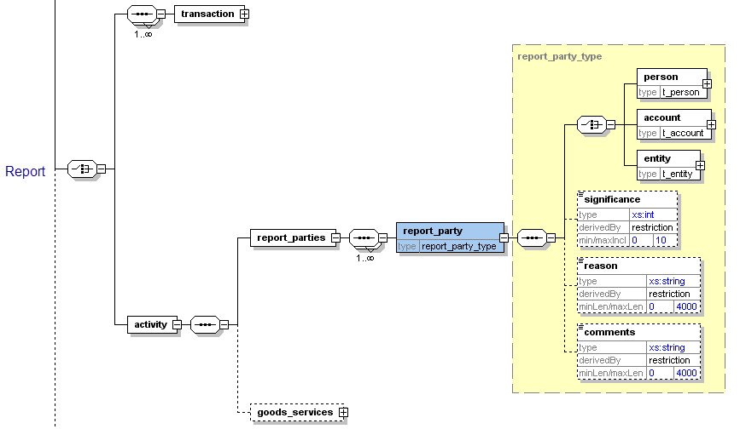

Figure 4: Overview node activity

|  |  |  |  |  |
| --- | --- | --- | --- | --- |
| **Name** | **Description** | **Length** | **Req.** | **Example** |
| **report_parties** | Represents a collection of involved subjects an involved subject with it’s details |  | **Y** |  |
| **report_party** | Represents a single involved subject with its details. At least one party should be included. | Type report_party_type | Y | See 4.9 Node report_party_type |
| goods_service | The standard goods_services node available in previous schemas | Type t_trans_item | N | - |

Table 4: Details node transaction

## 3.41 Node t_from_my_client

This node should be provided if the source side of the transaction is a client of the reporting bank. As on schema 4.0, entity could be a direct party in bi-party transactions

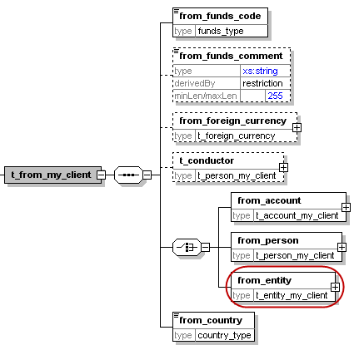

Figure 5: Overview node t_from_my_client

|  |  |  |  |  |
| --- | --- | --- | --- | --- |
| **Name** | **Description** | **Length** | **Req.** | **Example** |
| **from_funds_code** | Type of funds used in initiating transaction | Enumeration | **Y** | See 5.2 Funds type |
| from_funds_comment | Description, if funds_code is “O” (Other). | 255 | N | - |
| from_foreign_currency | If the transaction is conducted in foreign currency, then specify the foreign currency details. | type  t_foreign_currency | N | See 4.7 Type t_foreign_currency |
| t_conductor | The person performing the transaction. | type  t_person_my_client | N | See 4.31 Type t_person_my_client |
| **from_account** | Subnode that holds account information | type t_account_my_client | **Y**  (one of them only) | See 4.11 Type t_account_my_client |
| **from_person** | Subnode that holds “from person” information. | Type  t_person_my_client | See 4.31 Type t_person_my_client |
| **from_entity**  New in Schema 4.0 | Subnode that holds “from entity” information. | Type t_entity_my_client | See 4.32 Type t_entity_my_client |
| **from_country** | Country where transaction was initiated. | Enumeration | **Y** | See 5.14 Country Codes |

Table 5: Details node t_from_my_client

## 3.42 Node t_from

Source of the transaction. Can be either a person, an account or an entity. In case of a person source, as per Schema 3.0, the conductor could be different from the source person. As per schema 4.0,the entity could be a direct party in bi-party transactions

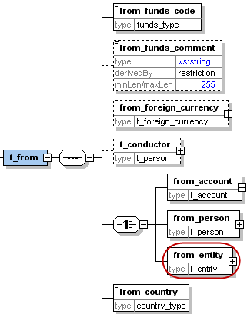

Figure 6: Overview node t_from

Note: Bi-directional transactions are composed of a source and destination. The source and destination may be either a person, an account or an entity (As per schema 4.0). For account deposits, the source is a person and the destination is an account i.e. on t_from side we will have from_person and on the t_to side we will have t_to_account. For account withdrawals, we will have from_account at the t_from side and to_person at the t_to side. For money remittances, we will have person to person transactions i.e. from_person at the t_from side and to_person at the t_to side. The same structure of person to person transactions can be used for any money service type of transaction. For account transfers, we will have account to account transactions i.e., from_account at the t_from side and to_account at the t_to side.

|  |  |  |  |  |
| --- | --- | --- | --- | --- |
| **Name** | **Description** | **Length** | **Req.** | **Example** |
| **from_funds_code** | Type of funds used in initiating transaction | Enumeration | **Y** | See 5.2 Funds type |
| from_funds_comment | Description, if funds_code is “O” (Other). | 255 | N | - |
| from_foreign_currency | If the transaction is conducted in foreign currency, then specify the foreign currency details. | type  t_foreign_currency | N | See 4.7 Type t_foreign_currency |
| t_conductor | The person performing the transaction. | type  t_person | N | See 4.32 Type t_person |
| **from_account** | Subnode that holds account information | type “t_account | **Y**  (one of them) | See *4.12 Type* t_account |
| **from_person** | Subnode that holds “from person” information. | type  “t_person” | See 4.32 Type t_person |
| **from_entity**  New in Schema 4.0 | Subnode that holds “from entity” information. | type “t_entity” | See 4.22 Type t_entity |
| **from_country** | Country where transaction was initiated. | Enumeration | **Y** | See 5.14 Country Codes |

Table 6: Details node t_from

## 

## 3.51 Node t_to_my_client

This node should be provided if the destination side of the transaction is a client of the reporting bank.

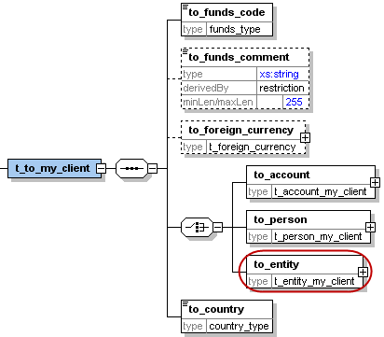

Figure 7: Overview node t_to_my_client

|  |  |  |  |  |
| --- | --- | --- | --- | --- |
| **Name** | **Description** | **Length** | **Req.** | **Example** |
| **to_funds_code** | Disposition of funds | Enumeration | **Y** | See 5.2 Funds type |
| to_funds_comment | Description, if funds_code is “O” (Other) or policy number. | 255 | N | - |
| to_foreign_currency | If the transaction is conducted in foreign currency, then specify the foreign currency details. | type  t_foreign_currency | N | See 4.7 Type t_foreign_currency |
| **to_account** | Subnode that holds account information | type t_account_my_client | **Y**  (one of them) | See *4.11 Type* t_account_my_client |
| **to_person** | Subnode that holds person information | type t_person_my_client | See 4.31 Type t_person_my_client |
| **to_entity**  New in Schema 4.0 | Subnode that holds “to entity” information. | Type t_entity_my_client | See 4.32 Type t_entity_my_client |
| **to_country** | Target country of the transaction | Enumeration | **Y** | See 5.14 Country Codes |

Table 7: Details node t_to_my_client

## 3.52 Node t_to

Information about the transaction disposition(s) - i.e. where the money went.

*t_to* can either point to a person or to an account.

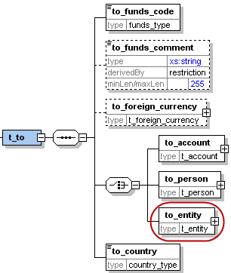

Figure 8: Overview node t_to

|  |  |  |  |  |
| --- | --- | --- | --- | --- |
| **Name** | **Description** | **Length** | **Req.** | **Example** |
| **to_funds_code** | Disposition of funds | Enumeration | **Y** | See 5.2 Funds type |
| to_funds_comment | Description, if funds_code is “O” (Other) or policy number. | 255 | N | - |
| to_foreign_currency | If the transaction is conducted in foreign currency, then specify the foreign currency details. | type  t_foreign_currency | N | See 4.7 Type t_foreign_currency |
| **to_account** | Subnode that holds account information | type t_account | **Y**  (one of them) | See *4.12 Type* t_account |
| **to_person** | Subnode that holds person information | type t_person | See 4.32 Type t_person |
| **to_entity**  New in Schema 4.0 | Subnode that holds “to entity” information. | Type t_entity | See 4.22 Type t_entity |
| **to_country** | Target country of the transaction | Enumeration | **Y** | See 5.14 Country Codes |

Table 8: Details node t_to

## 3.6 Subnode goods_services

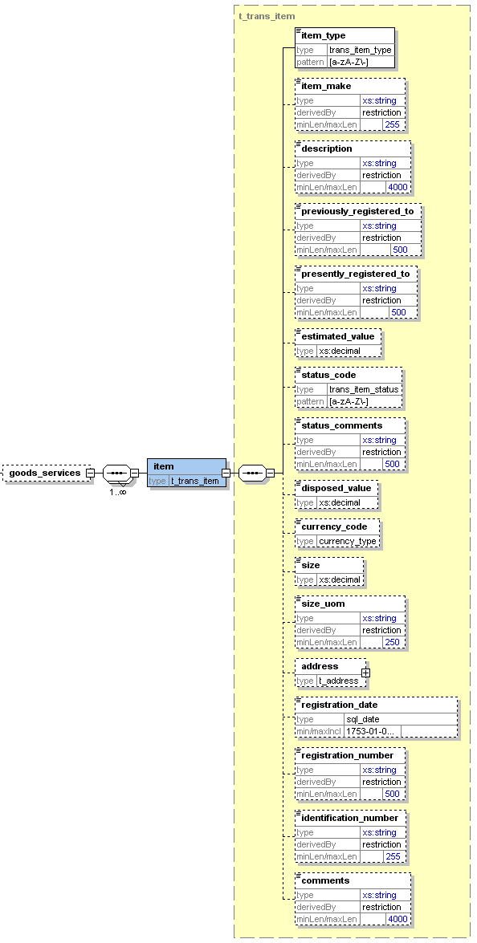

Figure 9: Overview subnode goods_services

|  |  |  |  |  |
| --- | --- | --- | --- | --- |
| **Name** | **Description** | **Length** | **Req.** | **Example** |
| **Item_type** | Lookup code describes the item type | Type “trans_item_type” | **Y** | C = Car  L = Land |
| Item_make | Item Maker | 255 | N | In case of Car for example, BMW |
| description | Text | 4000 | N | Apartment building |
| previously_registered_to | Name of previous owner | 500 | N | John Smith |
| presently_registered_to | Name of current owner | 500 | N | Jane Smith |
| estimated_value | Estimated value of the property – Used Currency is the one specified in node *from_currency* | Decimal | N | 250000.00 |
| status_code | Status code | Enumeration | N | See 5.7 Transaction Item Status |
| status_comments | Status Comments | 500 | N |  |
| disposed_value | effective value for property transfer – Used Currency is the one specified in node *from_currency* | Decimal | N | 500000.00 |
| Currency_code  (New in Schema 3.1) | used to report service conducted in foreign currency | Enumeration | **N** | See 5.13 Currencies |
| size | Size of the property – in unit specified in node *size_uom* | Decimal | N | 150 |
| size_uom | Unit of measurement | 250 | N | Square meters |
| address | Address of the property | type t_address | N | *4.5 Type* t_address |
| registration_date | Official registration date | DateTime | N | 2001-12-17T09:30:47 |
| registration_number | Official registration number | 500 | N | Car VIN Number |
| Identification_number | Any number that can identify the item | 255 | N | Car Plate Number |
| Comments | Additional comments | 4000 | N |  |

Table 9: Details subnode goods_services

# Description Of Common Types Used in the Schema

## *4.11 Type* t_account_my_client

The structure of this type is similar to that of type *t_account,*  with some added restrictions i.e. some nodes which are not mandatory in *t_account*  may be mandatory in *t_account_my_client.*

These restrictions are defined by the local FIU. The logic here is that whenever the involved account or person is the client of the reporting entity, more details may be demanded on the client, and the reporting entity must have the information as part of the adherence to the “Know Your Customer” (KYC) philosophy of compliance.

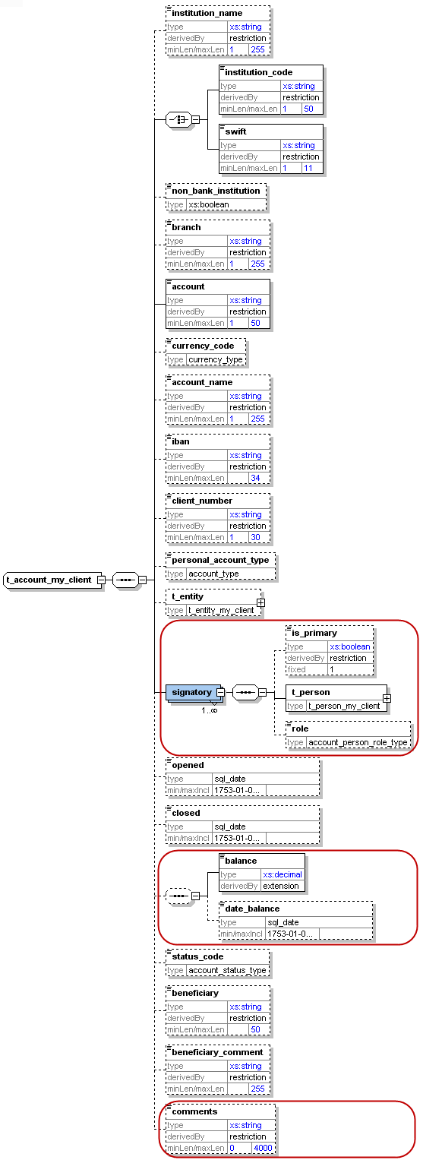

Figure 10: Overview type t_account_my_client

|  |  |  |  |  |
| --- | --- | --- | --- | --- |
| **Name** | **Description** | **Length** | **Req.** | **Example** |
| Instituation_name  (New in Schema 3.0) | The name of the Bank | 255 | N | Bank of … |
| **institution_code** | Institution code | 50 | **Y**  (one of them) | - |
| **swift** | SWIFT code according to ISO 9362 | 11 | ATTBVI |
| Non_bank_institution  (New is Schema 3.0) | A flag to cover cases where the account belongs to non-banking institution | Boolean | N | Investment company |
| **Branch**  *(enlarged in vesion. 3.1 to 255 chars)* | Branch code or name | 255 | N | ABX12 |
| **Account**  *(enlarged in vesion. 3.1 to 50 chars)* | Account number | 50 | **Y** | 31032027088 |
| **currency_code** | Currency the account is kept in | Enumeration | N | See 5.13 Currencies |
| **account_name**  *(enlarged in 3.1 to 255 chars)* | This is a free text field used to “Label” the account, for example a saving book account with anonymous owner, or an Entity account dedicated to Invoices, etc. | 255 | N | Private savings account |
| iban | IBAN | 34 | N | LT601010012345678901 |
| **client_number** | Client number | 30 | **Y** | 31032027088 |
| **personal_account_type** | Account Type | Enumeration | N | See 5.3 Account type |
| t_entity | Business entity owning the account | type  t_entity | N | See 4.22 Type t_entity |
| **signatory** | Person(s) with access to the account. | Subnode (can repeated to specify multiple signatories). Note that the node t_person is of type t_person_my_client | **Y** | - |
| is_primary | Identifies the primary account holder. Only one signatory may be marked as *is_primary.* Has to be ‘true’ when node is set. | fixed = 1 | N |  |
| **t_person** | Subnode holding detailed information about the signatory. Mandatory for signatories in the XML report. | type  t_person_my_client | **Y** | See 4.31 Type t_person_my_client |
| role  (New in Schema 4.0) | Subnode holding enumeration about the role of current signatory with the account. report. | type  “account_person_role_type” | N | See 5.154.31 Type t_person_my_client |
| **opened** | Date account opened | DateTime | N | 2003-01-25T00:00:00 |
| closed | Date account closed | DateTime | N | 2006-03-25T00:00:00 |
| **balance** | The account balance after the transaction was conducted. | Decimal | **Y** | 5000.50 |
| date_balance  (New in Schema 4.0) | A date to specify the date of the reported balance. Application will show balance history | DateTime | N | 2006-03-25T00:00:00 |
| **status_code** | Account status when transaction was initiated | Enumeration | **Y** | See 5.4 Account status type |
| **beneficiary** | Ultimatebeneficiary of the account | 50 | **Y** | Ella Machera |
| beneficiary_comment | Any special remark on the beneficiary | 255 | N |  |
| comments | Generic comments elements | 4000 | N |  |

Table 10: Details type t_account_my_client

## *4.12 Type* t_account

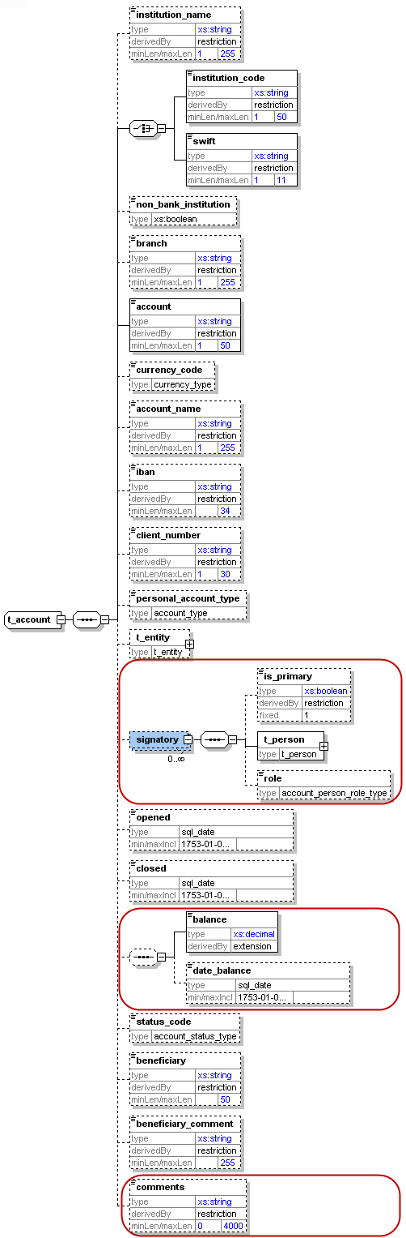

Figure 4: Overview type t_account

|  |  |  |  |  |
| --- | --- | --- | --- | --- |
| **Name** | **Description** | **Length** | **Req.** | **Example** |
| Instituation_name  (New in Schema 3.0) | The name of the Bank | 255 | N | Bank of … |
| **institution_code** | Institution code issued by FIU | 50 | **Y**  (one of them) | - |
| **swift** | SWIFT code according to ISO 9362 | 11 | ATTBVI |
| Non_bank_institution  (New is Schema 3.0) | A flag to cover cases where the account belongs to non-banking institution | Boolean | N | Investment company |
| Branch  (Increased to 255 chars in Schema 3.1) | Branch code or name | 255 | N | ABX12 |
| **Account**  (Increased to 50 chars in Schema 3.1) | Account number | 50 | **Y** | 31032027088 |
| currency_code | Currency the account is kept in | Enumeration | N | See 5.13 Currencies |
| account_name  (Increased to 255 chars in Schema 3.1) | This is a free text field used to “Label” the account; for example a saving book account with anonymous owner, or an Entity account dedicated to Invoices, etc. | 255 | N | Private savings account |
| iban | IBAN | 34 | N | LT601010012345678901 |
| client_number | Client number | 30 | N | 31032027088 |
| personal_account_type | Account Type | Enumeration | N | See 5.3 Account type |
| t_entity | Business entity owning the account | type  t_entity | N | See 4.22 Type t_entity |
| signatory | Person(s) with access to the account. | Subnode (can be repeated to specify multiple signatories).  Note that the node t_person is of type t_person | N | - |
| is_primary | Identifies the primary account holder. Only one signatory may be marked as *is_primary.* Has to be ‘true’ when node is set. | fixed = 1 | N |  |
| **t_person** | Subnode holding detailed information about the signatory. Mandatory for signatories in the XML report. | type  t_person | **Y** | See 4.32 Type t_person |
| role  (New in Schema 4.0) | Subnode holding enumeration about the role of current signatory with the account. report. | type  “account_person_role_type” | N | See 5.154.31 Type t_person_my_client |
| opened | Date account opened | DateTime | N | 2003-01-25T00:00:00 |
| closed | Date account closed | DateTime | N | 2006-03-25T00:00:00 |
| balance | The account balance after the transaction was conducted. | Decimal | N | 5000.50 |
| date_balance  (New in Schema 4.0) | A date field to specify the date of the reported balance. Application will show balance history | DateTime | N | 2006-03-25T00:00:00 | |
| status_code | Account status when transaction was initiated | Enumeration | N | See 5.4 Account status type |
| beneficiary | Ultimatebeneficiary of the account | 50 | N | Ella Machera |
| beneficiary_comment | Any special remark on the beneficiary | 255 | N |  |
| comments  (New in Schema 4.0) | Generic comments elements | 4000 | N |  | |

Table 4: Details type t_account

## 

## 4.21 Type t_entity_my_client

The structure of this type is similar to that of type *t_entity,*  with some added restrictions i.e. some nodes which are not mandatory in *t_entity*  may be mandatory in *t_entity_my_client*

These restrictions are defined by the local FIU.

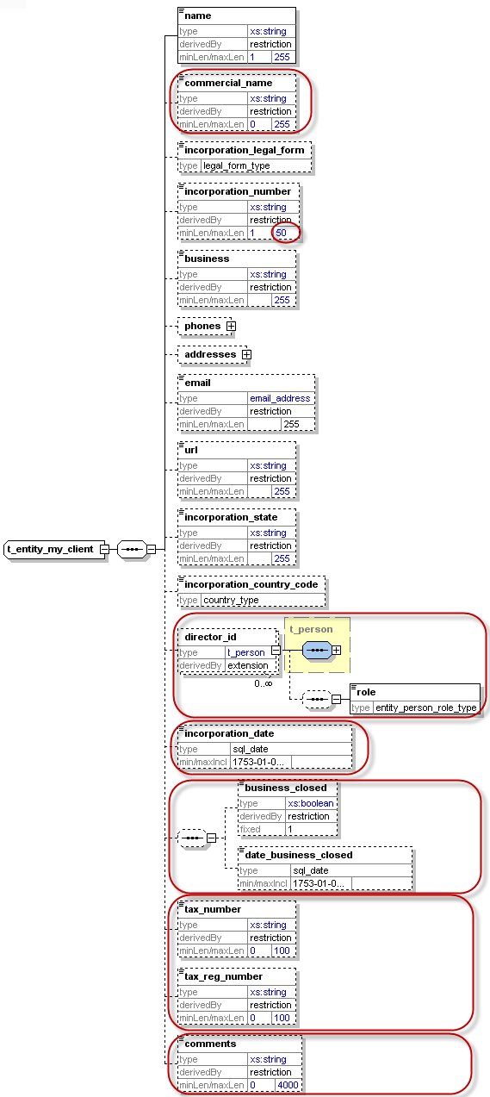

Figure 5: Overview type t_entity_my_client

|  |  |  |  |  |
| --- | --- | --- | --- | --- |
| **Name** | **Description** | **Length** | **Req.** | **Example** |
| **Name** | Name of Entity | 255 | **Y** | DoeComp |
| Commercial_name | The “traded as” name of the entity | 255 | N |  |
| Incorporation_legal_form  (New in Schema 3.0) | The legal form of the entity | Type “legal_form_type” | N | See 5.11  Ltd., GmbH, |
| **incorporation_number**  (Extended to 50 chars) | The registration number of the entity/"company" in the relevant authority (e.g. Chamber of Commerce) | 50 | N | - |
| **Business** | Business area of the entity | 255 | N | Free text describing business e.g. IT Services,Imports, Export etc. |
| **Phones**  (New in Schema 3.0) | A Holder node for a 1..many Phones |  | N |  |
| **Phone** | One occurrence of phone node | Type “t_phone” | N | See *4.6 Type* t_phone |
| **Addresses**  (New in Schema 3.0) | A Holder node for a 1..many Addresses |  | N |  |
| **Address** | One occurrence of address node | Type “t_address” | N | *4.5 Type* t_address |
| Email  (New in Schema 3.1) | Email address | email_address (255) | N | [test@mail.com](mailto:test@mail.com) |
| url | Entity web address | 255 | N | [www.entity.com](http://www.entity.com) |
| **incorporation_state** | Name of the State | 255 | N | - |
| **incorporation_country_code** | Country | Enumeration | N | See 5.14 Country Codes |
| **director_id**  This node has in 4.0 a new optional element **“role”** to describe the role of the subject in the entity from type entity_person_role_type | Individuals authorized | type t_person_my_client  (Subnode can be repeated for multiple persons) | N | See 4.31 Type t_person_my_client |
| incorporation_date  (New in schema 4.0) | Incorporation registration date | Date | N |  |
| business_closed  (New in schema 4.0) | Boolean to indicate if the company is closed down | Boolean | N |  |
| date_business_closed  (New in schema 4.0) | If entity is closed then specify close date if any. | Date | N |  |
| tax_numebr  (New in schema 4.0) | The entity tax number | 100 | N |  |
| tax_registeration_number  (New in schema 4.0) | Registration number of the entity by the Tax auth. | 100 | N |  |
| Comments  (New in schema 4.0) | Generic comments field | 4000 | N |  |

Table 5: Details type t_entity_my_client

## 4.22 Type t_entity

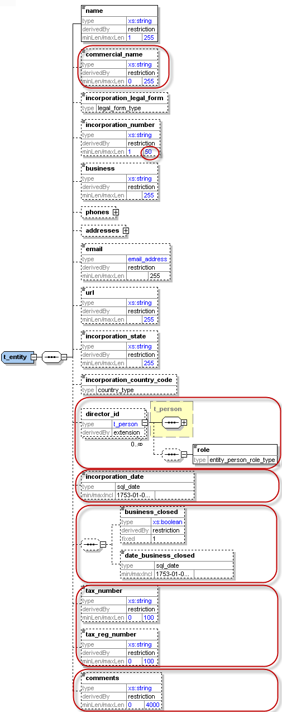

Figure 6: Overview type t_entity

|  |  |  |  |  |
| --- | --- | --- | --- | --- |
| **Name** | **Description** | **Length** | **Req.** | **Example** |
| **Name** | Name of Entity | 255 | **Y** | DoeComp |
| Commercial_name | The “traded as” name of the entity | 255 | N |  |
| Incorporation_legal_form  (New in Schema 3.0) | The legal form of the entity | Type “legal_form_type” | N | Ltd., GmbH, |
| incorporation_number  (Extended to 50 chars) | the registration number of the entity/"company" in the relevant authority (e.g. Chamber of Commerce) | 50 | N | - |
| Business | Business area of the entity | 255 | N | Text describing business e.g. IT Services,Imp, Exp etc. |
| Phones  (New in Schema 3.0) | A Holder node for a 1..many Phones |  | N |  |
| Phone | One occurrence of phone node | Type “t_phone” | N | See *4.6 Type* t_phone |
| Addresses  (New in Schema 3.0) | A Holder node for a 1..many Addresses |  | N |  |
| Address | One occurrence of address node | Type “t_address” | N | *4.5 Type* t_address |
| Email  (New in Schema 3.1) | Email address | email_address  (255) | N | [test@mail.com](mailto:test@mail.com) |
| url | Entity web address | 255 | N | [www.entity.com](http://www.entity.com) |
| incorporation_state | Name of the State | 255 | N | - |
| incorporation_country_code | Country | Enumeration | N | See 5.14 Country Codes |
| director_id  This node has in 4.0 a new optional element **“role”** to describe the role of the subject in the entity from type entity_person_role_type | Individuals authorized | type t_person | N | See 4.32 Type t_person |
| incorporation_date  (New in Schema 4.0) | Incorporation registration date | Date | N |  |
| business_closed  (New in Schema 4.0) | Boolean to indicate if the company is closed down | Boolean | N |  |
| date_business_closed  (New in Schema 4.0) | If entity is closed then specify close date if available | Date | N |  |
| tax_numebr  (New in Schema 4.0) | The entity tax number | 100 | N |  |
| tax_registeration_number  (New in Schema 4.0) | The registration number of the entity by the Tax authorities | 100 | N |  |
| comments  (New in Schema 4.0) | Generic comments field | 4000 | N |  |

Table 6: Details type t_entity

## 4.31 Type t_person_my_client

The structure of this type is similar to that of type *t_person,*  with some added restrictions i.e. some nodes which are not mandatory in *t_person*  may be mandatory in *t_person_my_client*

These restrictions are defined by the local FIU

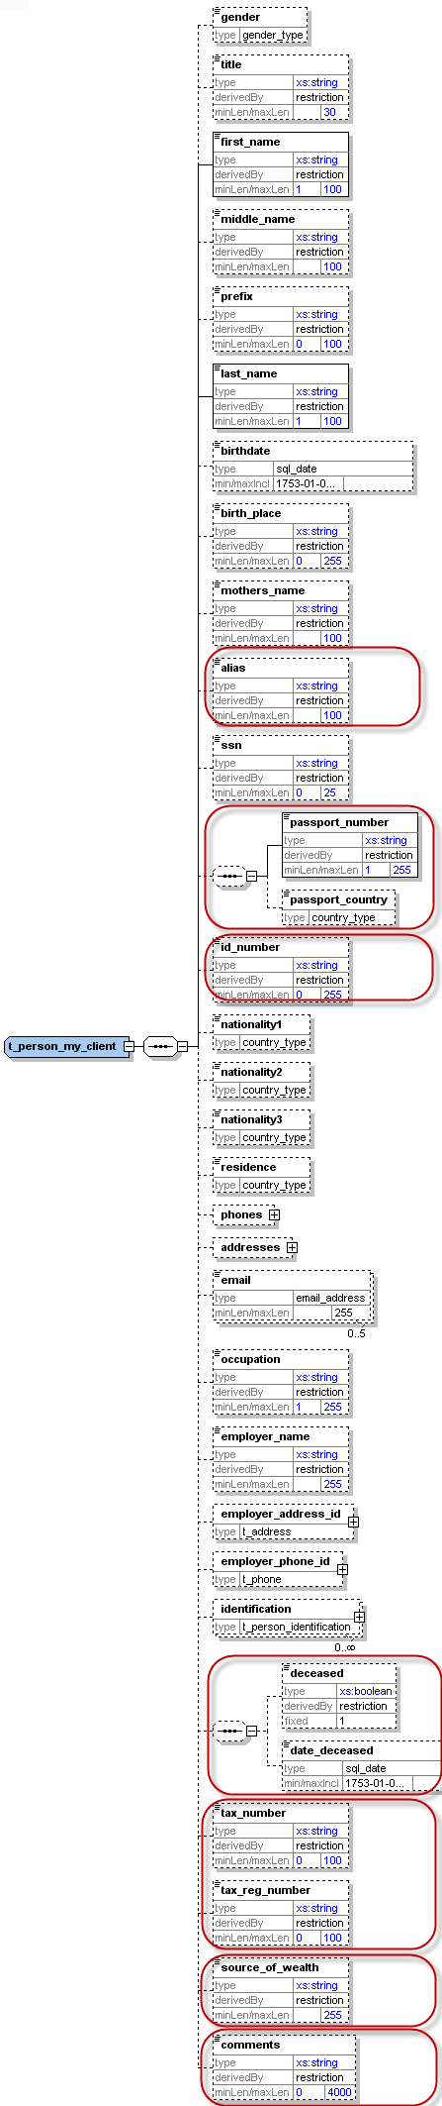

Figure 7: Overview type t_person_my_client

|  |  |  |  |  |
| --- | --- | --- | --- | --- |
| **Name** | **Description** | **Length** | **Req.** | **Example** |
| **gender** | Gender | Enumeration | **Y** | M or F |
| **Title** | Title | 30 | **Y** | Dr. |
| **first_name** | First name | 100 | **Y** | Elyas |
| middle_name | Middle name | 100 | N | X. |
| prefix | Prefix name | 100 | N | Van, Von,… |
| **last_name** | Last name | 100 | **Y** | Machera |
| Reporting entity should submit *birthdates* for persons who are their customers. | | | | |
| **birthdate** | Birth date | DateTime | **Y** | 1953-01-25T00:00:00 |
| Birth_place  (New in Schema 3.0) | Place of birth | 255 | N | Vienna |
| mothers_name | Can be used as father, mother, second name, Other name, etc. as per country’s regulation | 100 | N | Smith |
| Alias | Alias Name, Known as, ..etc | 100 | N |  |
| SSN  (New in Schema 3.0) | Social Security Number | 25 | N | National ID number which uniquely identify a person |
| passport_number  (New in Schema 4.0) | No. of passport | 25 | N | Passport num to be used as unification rule |
| passport_country  (New in Schema 4.0) | Passport issue country  (Can be reported only when there is a passport number) | 25 | N | Passport country to be used as unification rule |
| id_ number  (New in Schema 4.0) | Any additional identification number rather then ssn and passport | 25 | N | Additional identification number |
| **Phones**  (New in Schema 3.0) | A Holder node for a 1..many Phones |  | **Y** |  |
| **Phone** | One occurrence of phone node | Type “t_phone” | **Y** | See *4.6 Type* t_phone |
| **Addresses**  (New in Schema 3.0) | A Holder node for a 1..many Addresses |  | **Y** |  |
| **Address** | One occurrence of address node | Type t_address | **Y** | *4.5 Type* t_address |
| **Nationality1** | Country of Nationality (1) | Enumeration | **Y** | See 5.14 Country Codes |
| Nationality2  (New in Schema 3.0) | Country of Nationality (2) | Enumeration | N | See 5.14 Country Codes |
| Nationality3  (New in Schema 3.0) | Country of Nationality (3) | Enumeration | N | See 5.14 Country Codes |
| **residence** | Country of residence | Enumeration | **Y** | See 5.14 Country Codes |
| Email  (Enlarged in Schema 3.1 to 255 chars) | Email address | Type email_address  (255) | N | [test@mail.com](mailto:test@mail.com) |
| **Occupation**  *(enlarged in 3.1)* | Occupation | 255 | **Y** | Financial Analyst |
| employer_name  *(enlarged in 3.1)* | Employer’s name | 255 | N | FIU |
| employer_address_id | Employer’s address | type t_address | N | *4.5 Type* t_address |
| employer_phone_id | Employer’s phone | type t_phone | N | See 4.6 Type t_phone |
| **identification** | Subnode(s) for identification documents | type t_person_identification  (This subnode can be repeated to specify multiple identification documents) | **Y** | See 4.8 Type t_person_identification |
| deceased  (New in schema 4.0) | A Boolean to indicated if person has passed away | Boolean | N |  |
| deceased_date  (New in schema 4.0) | If deceased, then RE can report deceased date if known as well | Date | N |  |
| tax_numebr  (New in schema 4.0) | The person tax number | 100 | N |  |
| tax_reg_numebr  (New in schema 4.0) | The person tax reg. number by tax auth. | 100 | N |  |
| source_of_wealth  (New in schema 4.0) | Free text description of the person source of wealth | 255 | N |  |
| comments  (New in schema 4.0) | Generic comments field | 4000 | N |  |

Table 7: Details type t_person_my_client

## 4.32 Type t_person

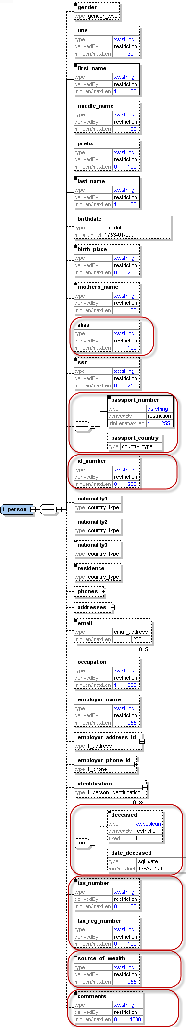

Figure 8: Overview type t_person

|  |  |  |  |  |
| --- | --- | --- | --- | --- |
| **Name** | **Description** | **Length** | **Req.** | **Example** |
| gender | Gender | Enumeration | N | M or F |
| Title | Title | 30 | N | Dr. |
| **first_name** | First name | 100 | **Y** | Elyas |
| middle_name | Middle name | 100 | N | X. |
| prefix | Prefix name | 100 | N | Van, Von,… |
| **last_name** | Last name | 100 | **Y** | Machera |
| birthdate | Birth date | DateTime | N | 1953-01-25T00:00:00 |
| Birth_place  (New in Schema 3.0) | Place of birth | 255 | N | Vienna |
| mothers_name | Can be used as father, mother, second name, Other name, etc. as per country’s regulation | 100 | N | Smith |
| alias | Alias, Known As, ..etc | 100 | N |  |
| SSN  (New in Schema 3.0) | Social Security Number | 25 | N | National ID number which uniquely identify a person |
| passport_number  (New in Schema 4.0) | No. of passport | 25 | N | Passport num to be used as unification rule |
| passport_country  (New in Schema 4.0) | Passport issue country  (Can be reported only when there is a passport number) | 25 | N | Passport country to be used as unification rule |
| id_ number  (New in Schema 4.0) | Any additional identification number rather then ssn and passport | 25 | N | Additional identification number |
| Phones  (New in Schema 3.0) | A Holder node for a 1..many Phones |  | N |  |
| Phone | One occurrence of phone node | Type “t_phone” | N | See *4.6 Type* t_phone |
| Addresses  (New in Schema 3.0) | A Holder node for a 1..many Addresses |  | N |  |
| Address | One occurrence of address node | Type t_address | N | *4.5 Type* t_address |
| Nationality1 | Country of Nationality (1) | Enumeration | N | See 5.14 Country Codes |
| Nationality2  (New in Schema 3.0) | Country of Nationality (2) | Enumeration | N | See 5.14 Country Codes |
| Nationality3  (New in Schema 3.0) | Country of Nationality (3) | Enumeration | N | See 5.14 Country Codes |
| residence | Country of residence | Enumeration | N | See 5.14 Country Codes |
| Email  *(Enlarged in Schema 3.1 to 255 chars)* | Email address | 255 | N | [test@mail.com](mailto:test@mail.com) |
| Occupation  *(enlarged in 3.1 to 255)* | Occupation | 255 | N | Financial Analyst |
| employer_name  *(enlarged in 3.1 to 255)* | Employer’s name | 255 | N | FIU |
| employer_address_id | Employer’s address | type t_address | N | *4.5 Type* t_address |
| employer_phone_id | Employer’s phone | type t_phone | N | See 4.6 Type t_phone |
| identification | Subnode(s) for identification documents | type t_person_identification  (This subnode can be repeated to specify multiple identification documents) | N | See 4.8 Type t_person_identification |
| deceased  (New in schema 4.0) | A Boolean to indicated if person has passed away | Boolean | N |  |
| deceased_date  (New in schema 4.0) | If deceased, then RE can report deceased date if known as well | Date | N |  |
| tax_numebr  (New in schema 4.0) | The person tax number | 100 | N |  |
| tax_reg_numebr  (New in schema 4.0) | The person tax reg. number by tax auth. | 100 | N |  |
| source_of_wealth  (New in schema 4.0) | Free text description of the person source of wealth | 255 | N |  |
| comments  (New in schema 4.0) | Generic comments field | 4000 | N |  |

Table 8: Details type t_person

## 4.4 Type t_party

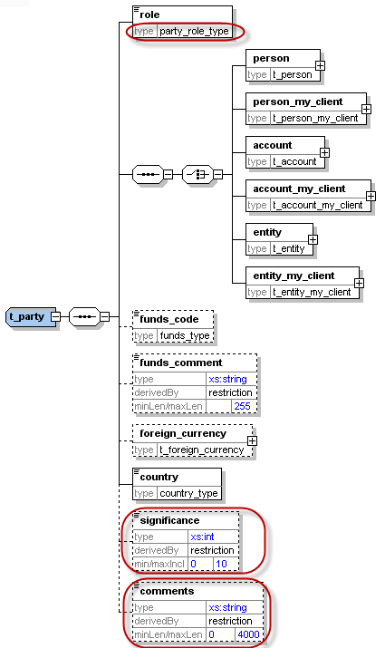

Figure 9: Overview type t_party

|  |  |  |  |  |
| --- | --- | --- | --- | --- |
| **Name** | **Description** | **Length** | **Req.** | **Example** |
| **role** | Subject role in the transaction | Enumeration | **Y** | Buyer, Seller,.. |
| Subject: One occurrence of the supported subject types must be included. | | | | |
| Person | Involved Person | Type “t_person” | **Y** | See 4.32 Type t_person |
| Person_my_client | Involved Person | Type “t_person_my_client” | **Y** | See 4.31 Type t_person_my_client |
| account | Involved Account | Type “t_account” | **Y** | See *4.12 Type* t_account |
| account_my_client | Involved Account | Type “t_ account_my_client” | **Y** | See *4.11 Type* t_account_my_client |
| entity | Involved Entity | Type “t_ entity” | **Y** | See 4.22 Type t_entity |
| entity_my_client | Involved Entity | Type “t_ entity_my_client” | **Y** |  |
| funds_code | Type of funds used in initiating transaction | Enumeration | N | See 5.2 Funds type |
| funds_comment | Description, if funds_code is “O” (Other). | 255 | N | - |
| foreign_currency | If the transaction is conducted in foreign currency, then specify the foreign currency details. | type  t_foreign_currency | N | See 4.7 Type t_foreign_currency |
| **country** | Country of the transaction | Enumeration | **Y** | See 5.14 Country Codes |
| significance  (New in schema 4.0) | The significance of the subject in the transaction | Integer | N | 0-10 |
| comments  (New in schema 4.0) | Generic comments | 4000 | N |  |

Table 9: Details type t_party

## *4.5 Type* t_address

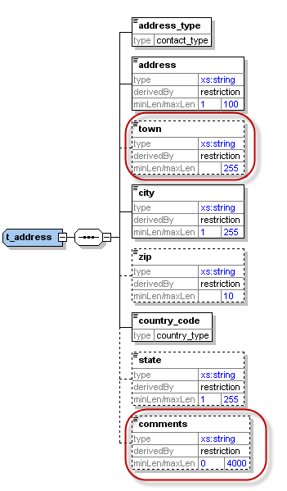

Figure 10: Overview type t_address

|  |  |  |  |  |
| --- | --- | --- | --- | --- |
| **Name** | **Description** | **Length** | **Req.** | **Example** |
| **Address_type**  (New in Schema 3.0) | The contact type of the address | Enumeration | **Y** | Private, Business,..  See 5.9 Contact Type |
| **Address** | Street name and house number | 100 | **Y** | - |
| Town | Name of Town/district/.. as part of a City | 255 | N |  |
| **City** | City | 255 | **Y** | - |
| Zip | Zip Code | 10 | N | A-1220 |
| **country_code** | Country | Enumeration | Y | See 5.14 Country Codes |
| State | State | 255 | N |  |
| comments  (New in schema 4.0) | Generic comments | 4000 | N |  |

able 10: Details type t_address

## 4.6 Type t_phone

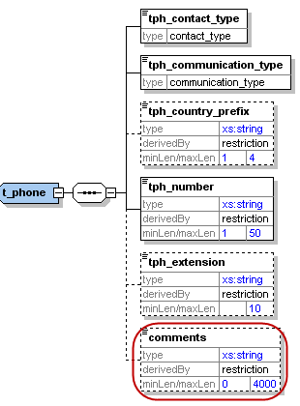

Figure 11: Overview type t_phone

|  |  |  |  |  |
| --- | --- | --- | --- | --- |
| **Name** | **Description** | **Length** | **Req.** | **Example** |
| **tph_contact_type**  (New in Schema 3.0) | The contact type of the Phone | Enumeration | **Y** | Private, Business,..  See 5.9 Contact Type |
| **tph_communication_type**  (New in Schema 3.0) | The comm.. type of the Phone | Enumeration | **Y** | Landline, mobile ,fax,..  5.10 Communication Type |
| tph_country_prefix | Country phone code | 4 | N | 0043 |
| **tph_number** | Phone number | 50 | **Y** | 6655778 |
| tph_extension | Phone’s extension | 10 | N | 7789 |
| comments  (New in schema 4.0) | Generic comments | 4000 | N |  |

Table 11: Details type t_phone

## 4.7 Type t_foreign_currency

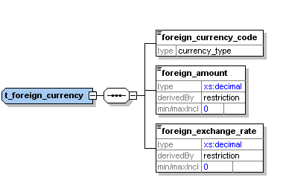

Figure 12: Overview type t_foreign_currency

|  |  |  |  |  |
| --- | --- | --- | --- | --- |
| **Name** | **Description** | **Length** | **Req.** | **Example** |
| **foreign_currency_code** | Currency Code according to ISO 4217 | Enumeration | **Y** | See 5.13 Currencies |
| **foreign_amount** | Transaction amount in foreign currency | Decimal | **Y** | 1300.50 |
| **foreign_exchange_rate** | Exchange rate which has been used for transaction | Decimal | **Y** | 1.45 |

Table 12: Details type t_foreign_currency

## 4.8 Type t_person_identification

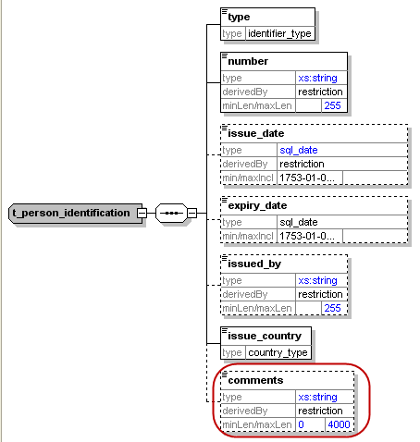

Figure 20: Overview type t_person_identification

|  |  |  |  |  |
| --- | --- | --- | --- | --- |
| **Name** | **Description** | **Length** | **Req.** | **Example** |
| **type** | Document type | Enumeration | **Y** | 5.5 Identifier type |
| **number** | ID of the identification document | 255 | **Y** | AT08154711 |
| issue_date | Identification document issue date | DateTime | N | 2001-12-17T09:30:47 |
| expiry_date | Identification document expiry date | DateTime | N | 2012-01-01T00:00:00 |
| issued_by  New in Schema 3.1 | Name of Authority issued the document | 255 | N | Interior Ministry |
| **issue_country** | Country where the document was issued | Enumeration | **Y** | See 5.14 Country Codes |
| comments | Generic comments field | 4000 | N |  |

Table 20: Type t_person_identification

## 4.9 Type report_party_type

New type in schema 4.0. Represents an involved subject in a report and its details.

Subject can be a Person, an Account or an Entity – one of them can be included per involved party.

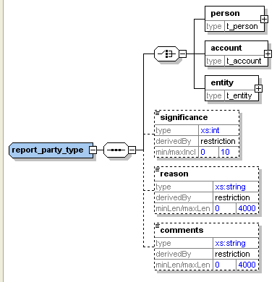

Figure 21: Overview type report_party_type

|  |  |  |  |  |  |  |  |  |  |
| --- | --- | --- | --- | --- | --- | --- | --- | --- | --- |
| **Name** | | **Description** | | **Length** | | **Req.** | | **Example** | |
| One of the following subject nodes must be included when activity node is used | | | | | | | | | |
| **person** | | Represents an involved person node | | t_person type | | **Y** | |  |
| **account** | | Represents an involved account | | t_account type | | **Y** | |  |
| **entity** | | Represents an involved entity | | t_entity type | | **Y** | |  |
| significance | | The significance of the subject in the report | | Integer | | N | | 0 - 10 | |
| reason | | Why the subject is involved in the current report | | 4000 | | N | |  | |
| comments | | Generic comments element | | 4000 | | N | |  | |

Table 21: Type report_party_type

# Lookup Values

As per schema 4.0, all schema lookups are defined as enumerations. goAML application will introduce an option to update the schema automatically with the lookup codes defined by the FIU in the “Lookup Master” screen. Reporting entities will not be able anymore to submit reports with undefined lookup codes.

Most of the lookup enumerations mentioned below are just predefined suggestions. Feel free to adjust them using “Lookup Master” screen.

## 5.1 Submission type – goAML Enumeration

|  |  |
| --- | --- |
| **Value** | **Description** |
| E | Electronically |
| M | Manually |

Table 13: submission type

## 5.2 Funds type

* The following list is a suggestion. Actual codes defined by FIU in “Lookup Master” will be added automatically to the Schema by goAML client application.

|  |  |
| --- | --- |
| **Value** | **Description** |
| A | Deposit |
| C | Currency exchange |
| D | Casino chips |
| E | Bank draft |
| F | Money order |
| G | Traveler’s cheques |
| H | Life insurance policy |
| I | Real estate |
| J | Securities |
| K | Cash |
| O | Other |
| P | Cheque |

Table 14: Funds type

## 5.3 Account type

*The following list is a suggestion. Actual codes defined by FIU in “Lookup Master” will be added automatically to the Schema by goAML client application.

|  |  |
| --- | --- |
| **Value** | **Description** |
| A | Business |
| B | Personal Current |
| C | Savings |
| D | Trust Account |
| E | Trading Account |
| O | Other |

Table 15: Account type

## 5.4 Account status type

*The following list is a suggestion. Actual codes defined by FIU in “Lookup Master” will be added automatically to the Schema by goAML client application.

|  |  |
| --- | --- |
| **Value** | **Description** |
| A | Active |
| B | Inactive |
| C | Dormant |

Table 16: Account status type

## 5.5 Identifier type

*The following list is a suggestion. Actual codes defined by FIU in “Lookup Master” will be added automatically to the Schema by goAML client application.

|  |  |
| --- | --- |
| **Value** | **Description** |
| A | Driver's license |
| B | Identity Card |
| C | Passport |
| O | Other |

Table 17: Identifier type

## 5.6 Conduction Type

*The following list is a suggestion. Actual codes defined by FIU in “Lookup Master” will be added automatically to the Schema by goAML client application.

|  |  |
| --- | --- |
| **Value** | **Description** |
| A | In-branch/Office |
| B | ATM |
| C | Electronic transaction |
| O | Other |

Table 25: Conduction Type

## 5.7 Transaction Item Status

*the following list is a suggestion. Actual codes defined by FIU in “Lookup Master” will be added automatically to the Schema by goAML client application.

|  |  |
| --- | --- |
| **Value** | **Description** |
| A | Bought |
| B | Sold |
| C | Let |
| D | Hired |
| E | Exchanged |
| F | Donated |
| G | Destroyed |
| H | Other |

Table 26: Transaction Item Status

## 

## 5.8 Report Code – goAML Enumeration

|  |  |
| --- | --- |
| **Value** | **Description** |
| CTR | Cash Transaction Report |
| STR | Suspicious Transaction Report |
| EFT | Electronic Funds Transfer |
| IFT | International Funds Transfer |
| TFR | Terror Financing Report |
| BCR | Border Cash Report |
| UTR | Unusual Transaction Report |
| AIF | Additional Information File – Can be used for example to get full disclosure of transactions of an account for a period of time without reporting it as a CTR. |
| IRI | Incoming Request for Information – International |
| ORI | Outgoing Request for Information – International |
| IRD | Incoming Request for Information – Domestic |
| ORD | Outgoing Request for Information – Domestic |

Table 27: Report Code

## 5.9 Contact Type

*The following list is a suggestion.

|  |  |
| --- | --- |
| **Value** | **Description** |
| B | Business |
| P | Private |
| O | Operational |
| R | Registered |
| - | Unknown |

Table 28: Contact Type

## 

## 5.10 Communication Type

*the following list is a suggestion. Actual codes defined by FIU in Lookup Master will be added automatically to the Schema by goAML client application.

|  |  |
| --- | --- |
| **Value** | **Description** |
| L | Landline Phone |
| M | Mobile Phone |
| F | Fax |
| S | Satellite Phone |
| P | Pager |
| - | Unknown |

Table 29: Communication Type

## 5.11 Entity Legal Form Type

* The following list is a suggestion. Actual codes defined by FIU in “Lookup Master” will be added automatically to the Schema by goAML client application.

|  |  |
| --- | --- |
| **Value** | **Description** |
| A | AG |
| G | GmbH |
| L | Ltd. |
| - | Unknown |

!Unexpected End of Formula

Table 30: Legal Form Type

## 5.12 Transaction Item Type

* The following list is a suggestion. Actual codes defined by FIU in “Lookup Master” will be added automatically to the Schema by goAML client application.

|  |  |
| --- | --- |
| **Value** | **Description** |
| L | Land |
| C | Car |
| - | Unknown |

Table 31: Transaction Item Type

## 5.13 Currencies - Enumeration

World Currencies (and their abbreviations) listed by ISO 4217

|  |  |
| --- | --- |
| ADP | Andorran Peseta (no longer in use) |
| AED | United Arab Emirates Dirham |
| AFA | Afghani |
| ALL | Leek |
| AMD | Dram |
| ANG | Netherlands Antilles Guilder |
| AOK | Kwanza |
| AON | New Kwanza |
| ARA | Austral |
| ARP | Argentinean Peso |
| ARS | Argentinean Nuevo Peso |
| ATS | Schilling (no longer in use) |
| AUD | Australian Dollar |
| AWG | Aruban Guilder |
| AZM | Azerbaijani Manat |
| BAM | Convertible Mark |
| BBD | Barbados Dollar |
| BDT | Taka |
| BEC | Convertible Belgian Franc (no longer in use) |
| BEF | Belgian Franc (also known as Frank - no longer in use) |
| BEL | Financial Belgian Franc (no longer in use) |
| BGL | Lev |
| BHD | Bahraini Dinar |
| BIF | Burundi Franc |
| BMD | Bermudian Dollar |
| BND | Brunei Dollar |
| BOB | Boliviano |
| BOP | Bolivian Peso |
| BRC | Cruzeiro |
| BRL | Real |
| BRR | Cruzeiro Real |
| BSD | Bahamian Dollar |
| BTN | Ngultrum |
| BUK | Replaced by MMK |
| BWP | Pula |
| BYR | Belarussian Rouble |
| BZD | Belize Dollar |
| CAD | Canadian Dollar |
| CDF | Congolese Franc |
| CDZ | New Zaïre |
| CHF | Swiss Franc |
| CLF | Unidades de Fomento |
| CLP | Chilean Peso |
| CNY | Yuan Renminbi |
| COP | Colombian Peso |
| CRC | Costa Rican Colón |
| CSK | Koruna of former Czechoslovakia. Now replaced by CZK (Czech Koruna) and SKK (Slovak Koruna) |
| CUP | Cuban Peso |
| CVE | Escudo Caboverdiano |
| CYP | Cypriot Pound |
| CZK | Czech Koruna |
| DDM | Former East German Mark, DEM subsequently in use |
| DEM | Deutsche Mark (no longer in use) |
| DJF | Djibouti Franc |
| DKK | Danish Krone |
| DOP | Dominican Republic Peso |
| DZD | Algerian Dinar |
| ECS | Sucre (no longer in use) |
| EEK | Kroon |
| EGP | Egyptian Pound |
| ERN | Eritrean Nakfa |
| ESA | Spanish Peseta, Account A (no longer in use) |
| ESB | Spanish Peseta, Account B (no longer in use) |
| ESP | Spanish Peseta (no longer in use) |
| ETB | Ethiopian Birr |
| EUR | Euro |
| FIM | Markka (no longer in use) |
| FJD | Fiji Dollar |
| FKP | Falkland Pound |
| FRF | French Franc (no longer in use) |
| GBP | Pound Sterling (United Kingdom Pound) |
| GEL | Lari |
| GHC | Cedi |
| GIP | Gibraltar Pound |
| GMD | Dalasi |
| GNS | Syli (also known as Guinea Franc) |
| GQE | Ekwele |
| GRD | Greek Drachma (no longer in use) |
| GTQ | Quetzal |
| GWP | Guinea-Bissau Peso |
| GYD | Guyana Dollar |
| HKD | Hong Kong Dollar |
| HNL | Lempira |
| HRD | Croatian Dinar |
| HRK | Croatian Kuna |
| HTG | Gourde |
| HUF | Forint |
| IDR | Rupiah |
| IEP | Punt (no longer in use) |
| ILS | Shekel |
| INR | Indian Rupee |
| IQD | Iraqi Dinar |
| IRR | Iranian Rial |
| ISK | Icelandic Króna |
| ITL | Italian Lira (no longer in use) |
| JMD | Jamaican Dollar |
| JOD | Jordanian Dinar |
| JPY | Yen |
| KES | Kenyan Shilling |
| KGS | Kyrgyzstani Som |
| KHR | Riel |
| KMF | Comorian Franc |
| KPW | Democratic People's Republic of Korean Won |
| KRW | Republic of Korean Won |
| KWD | Kuwaiti Dinar |
| KYD | Cayman Islands Dollar |
| KZT | Tenge |
| LAK | Kip |
| LBP | Lebanese Pound |
| LKR | Sri Lankan Rupee |
| LRD | Liberian Dollar |
| LSL | Loti |
| LSM | Maloti |
| LTL | Litas |
| LUF | Luxembourg Franc (no longer in use) |
| LVL | Lats |
| LYD | Libyan Dinar |
| MAD | Moroccan Dirham |
| MDL | Moldavian Leu |
| MGF | Malagasy Franc |
| MKD | Macedonian Dinar |
| MLF | Malian Franc |
| MMK | Kyat |
| MNT | Tugrik |
| MOP | Pataca |
| MRO | Ouguiya |
| MTL | Maltese Lira |
| MTP | Maltese Pound, replaced by Maltese Lira |
| MUR | Mauritius Rupee |
| MVR | Rufiyaa |
| MWK | Malawian Kwacha |
| MXN | Mexican New Peso (replacement for Mexican Peso) |
| MXP | Mexican Peso, replaced by Mexican New Peso |
| MYR | Ringgit (also known as Malaysian Dollar) |
| MZM | Metical |
| NAD | Namibian Dollar |
| NGN | Naira |
| NIC | Córdoba |
| NLG | Dutch Guilder (no longer in use) |
| NOK | Norwegian Krone |
| NPR | Nepalese Rupee |
| NZD | New Zealand Dollar |
| OMR | Omani Rial |
| PAB | Balboa |
| PEI | Inti |
| PEN | New Sol |
| PES | Sol (replaced by New Sol [PEN]) |
| PGK | Kina |
| PHP | Philippines Peso |
| PKR | Pakistani Rupee |
| PLN | New Zloty |
| PLZ | Zloty (replaced by New Zloty [PLN]) |
| PTE | Portuguese Escudo (no longer in use) |
| PYG | Guarani |
| QAR | Qatari Riyal |
| ROL | Romanian Leu |
| RSD | Serbian Dinar |
| RUB | Russian Federation Rouble (formerly RUR) |
| RWF | Rwandan Franc |
| SAR | Saudi Riyal |
| SBD | Solomon Islands Dollar |
| SCR | Seychelles Rupee |
| SDD | Sudanese Dinar |
| SDP | Sudanese Pound |
| SEK | Swedish Krona |
| SGD | Singapore Dollar |
| SHP | St Helena Pound |
| SIT | Tolar |
| SKK | Slovak Koruna |
| SLL | Leone |
| SOS | Somali Shilling |
| SRG | Surinam Guilder |
| STD | Dobra |
| SUR | Union of Soviet Socialist Republics Rouble |
| SVC | El Salvadorian Colón |
| SYP | Syrian Pound |
| SZL | Lilangeni |
| THB | Baht |
| TJR | Tajik Rouble |
| TMM | Turkmenistani Manat |
| TND | Tunisian Dinar |
| TOP | Pa'anga |
| TPE | Timorian Escudo |
| TRL | Turkish Lira |
| TTD | Trinidad and Tobago Dollar |
| TWD | Taiwan Dollar |
| TZS | Tanzanian Shilling |
| UAH | Hryvna |
| UAK | Karbovanet |
| UGS | Ugandan Shilling |
| UKP | Incorrectly used for GBP |
| USD | United States Dollar |
| USN | United States Dollar (Next day) |
| USS | United States Dollar (Same day) |
| UYP | Uruguayan Peso, replaced by Uruguayan New Peso (UYU) |
| UYU | Uruguayan New Peso |
| UZS | Uzbekistani Som |
| VEB | Bolivar |
| VND | Viet Nam Dông |
| VUV | Vatu |
| WST | Tala |
| XAF | Franc de la Communauté financière africaine |
| XAU | Gold |
| XBA | European Composite Unit |
| XBB | European Monetary Unit |
| XBC | European Unit of Account 9 |
| XBD | European Unit of Account 17 |
| XCD | East Caribbean Dollar |
| XDR | International Monetary Fund Special Drawing Rights |
| XEU | ECU (not an official currency, replaced by the Euro) |
| XOF | West African Franc |
| XPF | Franc des Comptoirs français du Pacifique |
| YDD | South Yemeni Dinar |
| YER | Yemeni Riyal |
| YUD | Yugoslavian New Dinar (no longer in use) |
| ZAL | Rand (financial) |
| ZAR | Rand |
| ZMK | Zambian Kwacha |
| ZRZ | Replaced by CDZ |
| ZWD | Zimbabwe Dollar |

Table 32: Currency Codes

## 5.14 Country Codes - Enumeration

This list states the country names (official short names in English) in alphabetical order as given in ISO 3166-1 and the corresponding ISO 3166-1-alpha-2 code elements.

|  |  |
| --- | --- |
| **Value** | **Description** |
| AD | ANDORRA |
| AE | UNITED ARAB EMIRATES |
| AF | AFGHANISTAN |
| AG | ANTIGUA AND BARBUDA |
| AI | ANGUILLA |
| AL | ALBANIA |
| AM | ARMENIA |
| AN | NETHERLANDS ANTILLES |
| AO | ANGOLA |
| AQ | ANTARCTICA |
| AR | ARGENTINA |
| AS | AMERICAN SAMOA |
| AT | AUSTRIA |
| AU | AUSTRALIA |
| AW | ARUBA |
| AX | ÅLAND ISLANDS |
| AZ | AZERBAIJAN |
| BA | BOSNIA AND HERZEGOVINA |
| BB | BARBADOS |
| BD | BANGLADESH |
| BE | BELGIUM |
| BF | BURKINA FASO |
| BG | BULGARIA |
| BH | BAHRAIN |
| BI | BURUNDI |
| BJ | BENIN |
| BM | BERMUDA |
| BN | BRUNEI DARUSSALAM |
| BO | BOLIVIA |
| BR | BRAZIL |
| BS | BAHAMAS |
| BT | BHUTAN |
| BU | BURMA |
| BV | BOUVET ISLAND |
| BW | BOTSWANA |
| BY | BELARUS |
| BZ | BELIZE |
| CA | CANADA |
| CC | COCOS (KEELING) ISLANDS |
| CD | CONGO, THE DEMOCRATIC REPUBLIC OF THE |
| CF | CENTRAL AFRICAN REPUBLIC |
| CG | CONGO |
| CH | SWITZERLAND |
| CI | COTE D'IVOIRE |
| CK | COOK ISLANDS |
| CL | CHILE |
| CM | CAMEROON |
| CN | CHINA |
| CO | COLOMBIA |
| CR | COSTA RICA |
| CS | SERBIA AND MONTENEGRO |
| CU | CUBA |
| CV | CAPE VERDE |
| CX | CHRISTMAS ISLAND |
| CY | CYPRUS |
| CZ | CZECH REPUBLIC |
| DE | GERMANY |
| DJ | DJIBOUTI |
| DK | DENMARK |
| DM | DOMINICA |
| DO | DOMINICAN REPUBLIC |
| DZ | ALGERIA |
| EC | ECUADOR |
| EE | ESTONIA |
| EG | EGYPT |
| EH | WESTERN SAHARA |
| ER | ERITREA |
| ES | SPAIN |
| ET | ETHIOPIA |
| FI | FINLAND |
| FJ | FIJI |
| FK | FALKLAND ISLANDS (MALVINAS) |
| FM | MICRONESIA, FEDERATED STATES OF |
| FO | FAROE ISLANDS |
| FR | FRANCE |
| GA | GABON |
| GB | UNITED KINGDOM |
| GD | GRENADA |
| GE | GEORGIA |
| GF | FRENCH GUIANA |
| GG | GUERNSEY |
| GH | GHANA |
| GI | GIBRALTAR |
| GL | GREENLAND |
| GM | GAMBIA |
| GN | GUINEA |
| GP | GUADELOUPE |
| GQ | EQUATORIAL GUINEA |
| GR | GREECE |
| GS | SOUTH GEORGIA AND THE SOUTH SANDWICH ISLANDS |
| GT | GUATEMALA |
| GU | GUAM |
| GW | GUINEA-BISSAU |
| GY | GUYANA |
| HK | HONG KONG |
| HM | HEARD ISLAND AND MCDONALD ISLANDS |
| HN | HONDURAS |
| HR | CROATIA |
| HT | HAITI |
| HU | HUNGARY |
| ID | INDONESIA |
| IE | IRELAND |
| IL | ISRAEL |
| IM | ISLE OF MAN |
| IN | INDIA |
| IO | BRITISH INDIAN OCEAN TERRITORY |
| IQ | IRAQ |
| IR | IRAN, ISLAMIC REPUBLIC OF |
| IS | ICELAND |
| IT | ITALY |
| JE | JERSEY |
| JM | JAMAICA |
| JO | JORDAN |
| JP | JAPAN |
| KE | KENYA |
| KG | KYRGYZSTAN |
| KH | CAMBODIA |
| KI | KIRIBATI |
| KM | COMOROS |
| KN | SAINT KITTS AND NEVIS |
| KP | KOREA, DEMOCRATIC PEOPLE'S REPUBLIC OF |
| KR | KOREA, REPUBLIC OF |
| KS | KOSOVO |
| KW | KUWAIT |
| KY | CAYMAN ISLANDS |
| KZ | KAZAKHSTAN |
| LA | LAO PEOPLE'S DEMOCRATIC REPUBLIC |
| LB | LEBANON |
| LC | SAINT LUCIA |
| LI | LIECHTENSTEIN |
| LK | SRI LANKA |
| LR | LIBERIA |
| LS | LESOTHO |
| LT | LITHUANIA |
| LU | LUXEMBOURG |
| LV | LATVIA |
| LY | LIBYAN ARAB JAMAHIRIYA |
| MA | MOROCCO |
| MC | MONACO |
| MD | MOLDOVA, REPUBLIC OF |
| ME | MONTENEGRO |
| MG | MADAGASCAR |
| MH | MARSHALL ISLANDS |
| MK | MACEDONIA |
| ML | MALI |
| MM | MYANMAR |
| MN | MONGOLIA |
| MO | MACAO |
| MP | NORTHERN MARIANA ISLANDS |
| MQ | MARTINIQUE |
| MR | MAURITANIA |
| MS | MONTSERRAT |
| MT | MALTA |
| MU | MAURITIUS |
| MV | MALDIVES |
| MW | MALAWI |
| MX | MEXICO |
| MY | MALAYSIA |
| MZ | MOZAMBIQUE |
| NA | NAMIBIA |
| NC | NEW CALEDONIA |
| NE | NIGER |
| NF | NORFOLK ISLAND |
| NG | NIGERIA |
| NI | NICARAGUA |
| NL | NETHERLANDS |
| NO | NORWAY |
| NP | NEPAL |
| NR | NAURU |
| NU | NIUE |
| NZ | NEW ZEALAND |
| OM | OMAN |
| PA | PANAMA |
| PE | PERU |
| PF | FRENCH POLYNESIA |
| PG | PAPUA NEW GUINEA |
| PH | PHILIPPINES |
| PK | PAKISTAN |
| PL | POLAND |
| PM | SAINT PIERRE AND MIQUELON |
| PN | PITCAIRN |
| PR | PUERTO RICO |
| PS | PALESTINIAN TERRITORY, OCCUPIED |
| PT | PORTUGAL |
| PW | PALAU |
| PY | PARAGUAY |
| QA | QATAR |
| RE | REUNION |
| RO | ROMANIA |
| RS | SERBIA |
| RU | RUSSIAN FEDERATION |
| RW | RWANDA |
| SA | SAUDI ARABIA |
| SB | SOLOMON ISLANDS |
| SC | SEYCHELLES |
| SD | SUDAN |
| SE | SWEDEN |
| SG | SINGAPORE |
| SH | SAINT HELENA |
| SI | SLOVENIA |
| SJ | SVALBARD AND JAN MAYEN |
| SK | SLOVAKIA |
| SL | SIERRA LEONE |
| SM | SAN MARINO |
| SN | SENEGAL |
| SO | SOMALIA |
| SR | SURINAME |
| ST | SAO TOME AND PRINCIPE |
| SV | EL SALVADOR |
| SY | SYRIAN ARAB REPUBLIC |
| SZ | SWAZILAND |
| TC | TURKS AND CAICOS ISLANDS |
| TD | CHAD |
| TF | FRENCH SOUTHERN TERRITORIES |
| TG | TOGO |
| TH | THAILAND |
| TJ | TAJIKISTAN |
| TK | TOKELAU |
| TL | TIMOR-LESTE |
| TM | TURKMENISTAN |
| TN | TUNISIA |
| TO | TONGA |
| TP | EAST TIMOR |
| TR | TURKEY |
| TT | TRINIDAD AND TOBAGO |
| TV | TUVALU |
| TW | TAIWAN, PROVINCE OF CHINA |
| TZ | TANZANIA, UNITED REPUBLIC OF |
| UA | UKRAINE |
| UG | UGANDA |
| UM | UNITED STATES MINOR OUTLYING ISLANDS |
| US | UNITED STATES |
| UY | URUGUAY |
| UZ | UZBEKISTAN |
| VA | HOLY SEE (VATICAN CITY STATE) |
| VC | SAINT VINCENT AND THE GRENADINES |
| VE | VENEZUELA |
| VG | VIRGIN ISLANDS, BRITISH |
| VI | VIRGIN ISLANDS, U.S. |
| VN | VIET NAM |
| VU | VANUATU |
| WF | WALLIS AND FUTUNA |
| WS | SAMOA |
| YE | YEMEN |
| YT | MAYOTTE |
| YU | YUGOSLAVIA |
| ZA | SOUTH AFRICA |
| ZM | ZAMBIA |
| ZR | ZAIRE |
| ZW | ZIMBABWE |

Table 33: Country Codes

## 5.15 account_person_role_type

* The following list is a suggestion. Actual codes defined by FIU in “Lookup Master” will be added automatically to the Schema by goAML client application.

.

|  |  |
| --- | --- |
| **Value** | **Description** |
| --- | Default value |
|  |  |

## 5.16 entity_person_role_type

*The following list is a suggestion. Actual codes defined by FIU in “Lookup Master” will be added automatically to the Schema by goAML client application.

.

|  |  |
| --- | --- |
| **Value** | **Description** |
| --- | Default value |
|  |  |